AiNetsoft Functions Description

- Users:
- In case of normal users, the screen appear in general as below
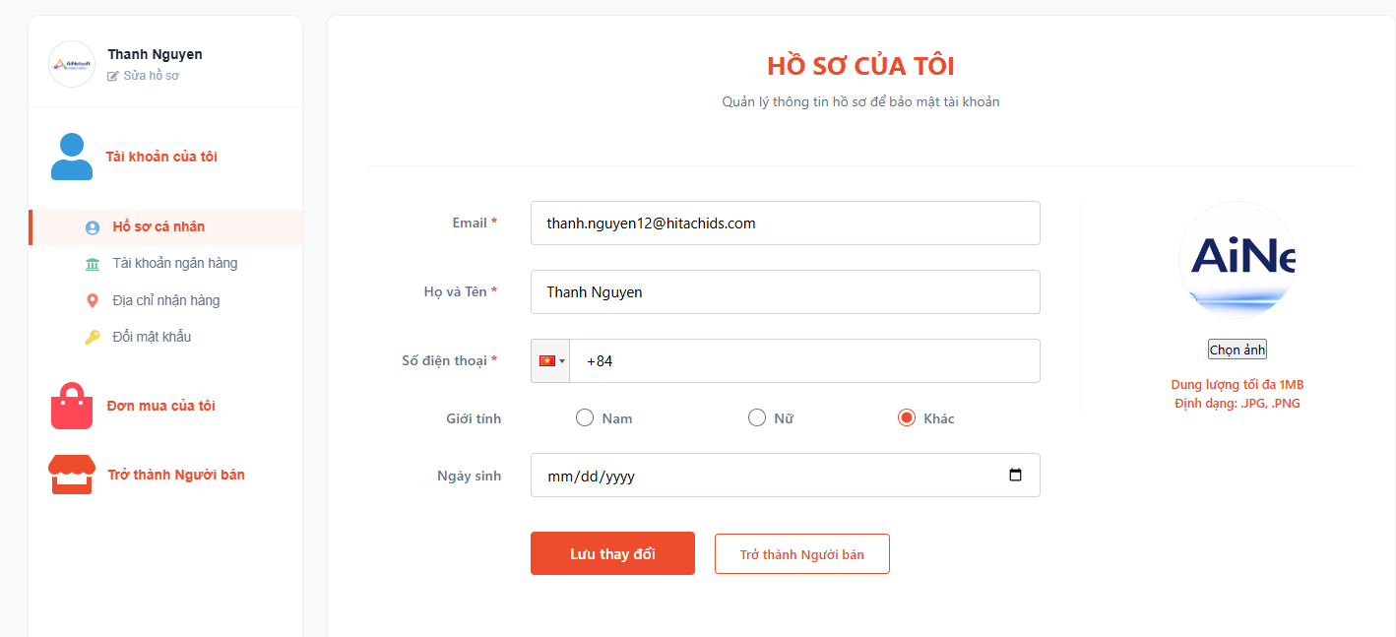
Normal users can edit their information via each page
- Edit all needed fields as the “ Ho so ca nhan”. The scenario that Phone number can be sync from the Sell request data to this page, also same for email. Data is storing in the User collection
- Tài khoản ngân hang is being stored in the bank_account collection. This also be sync when user request to become a Seller
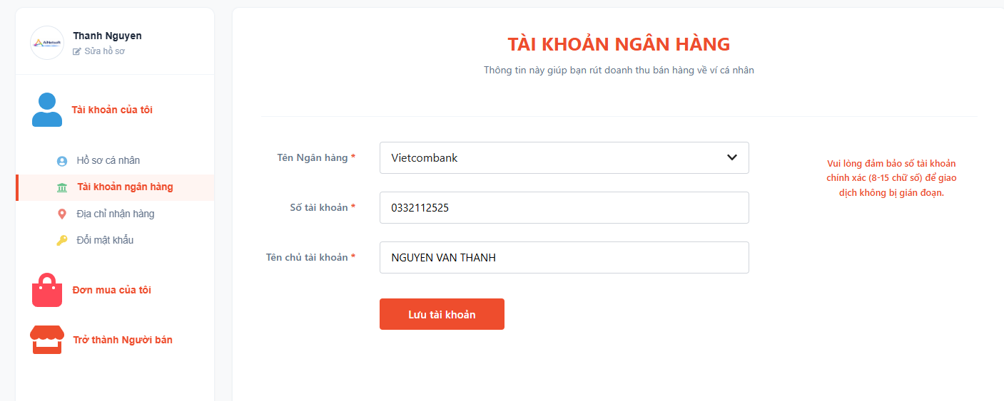
- Địa chỉ nhận hang: Users can update data here. This is also synced to the Seller registry from if use request to become a Seller
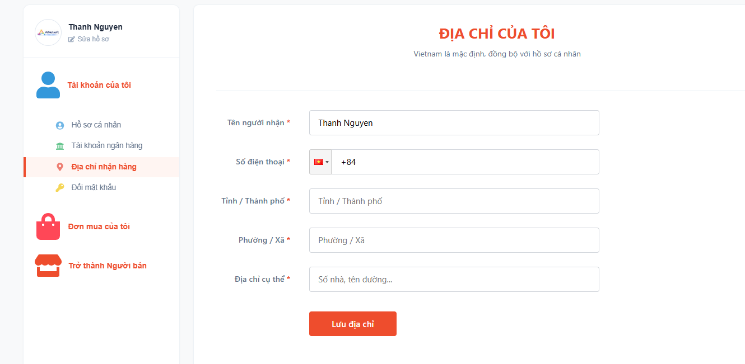
- Change password: The change password is offered here. Future will implement a validation email account to make sure fake email is not available. Also the password constrain will be asked for stronger.
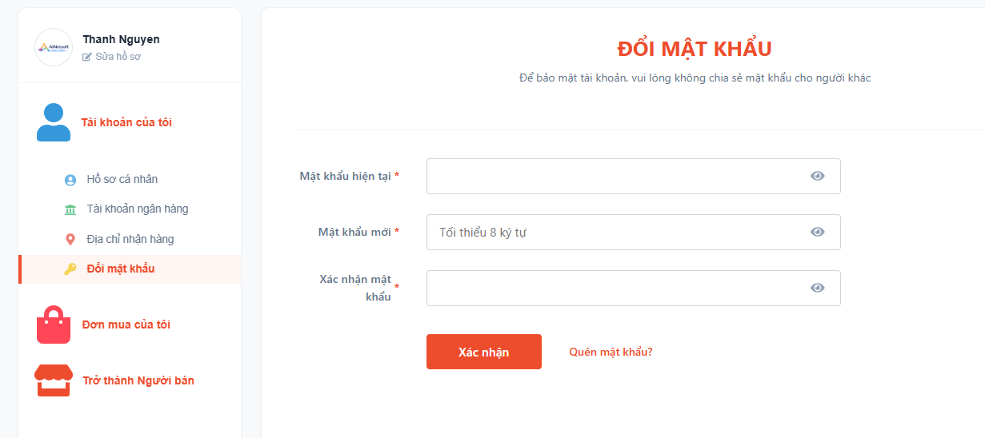
- Users purchasing status: Users can track their purchasing status here
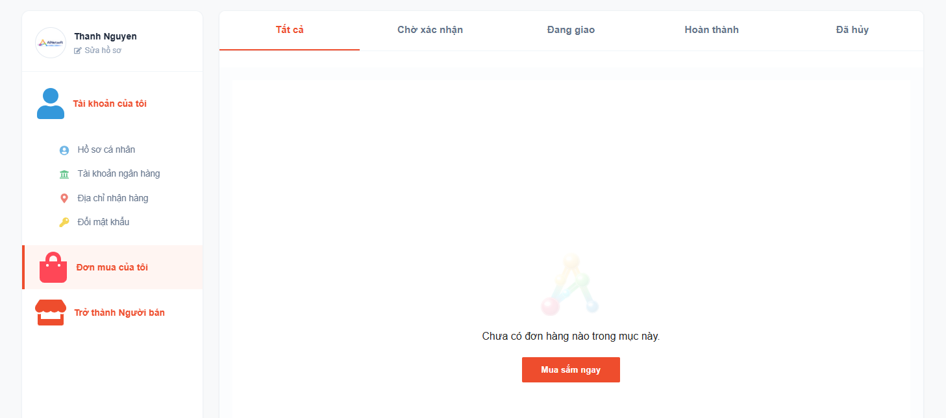

- Become a seller: This contains a huge complex steps to register to become a Seller with using AI connection service support to scan to detect the fake CCCD info
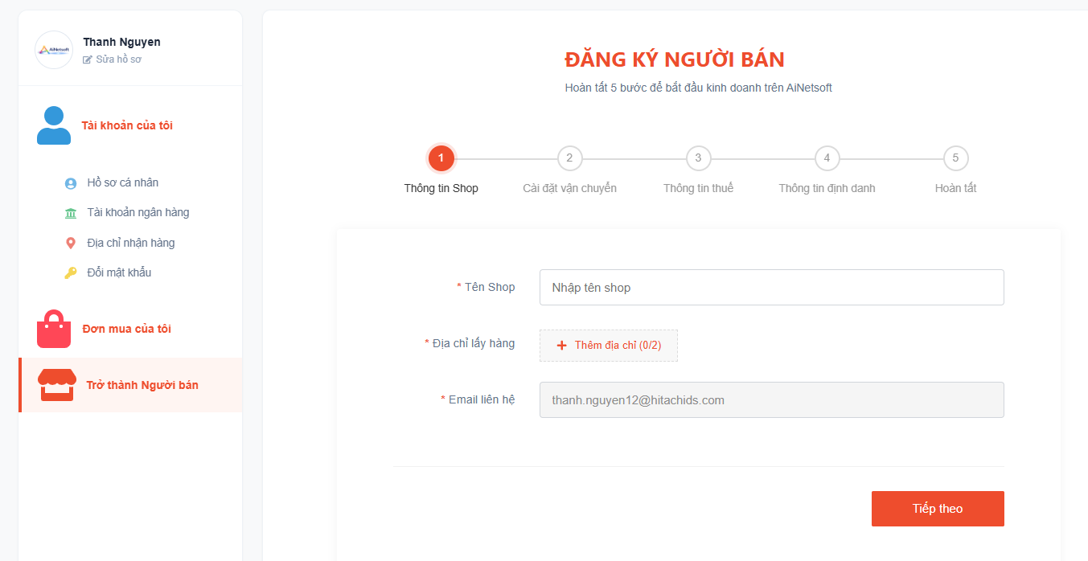
- Seller:
- Register to become a seller:
Step 1 to become a seller:


Details address steps
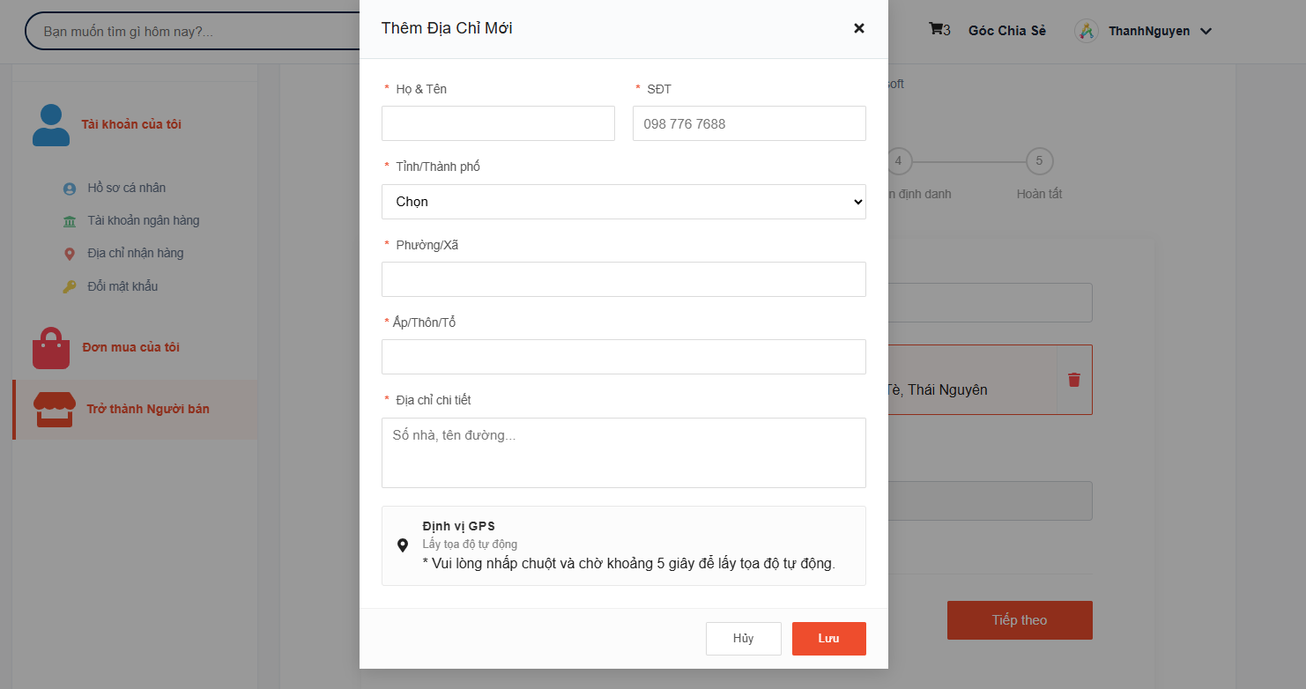

Users must fill in sufficient information to ensure this request is approved by Admin board
Next screen that asks users to fill the method of transportation
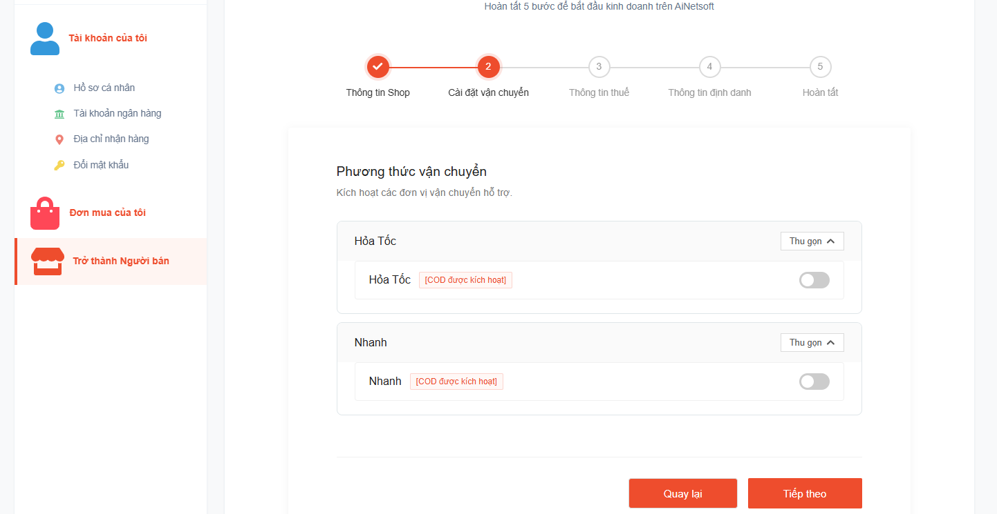

Users must type the business type and full fill sufficient info and validation
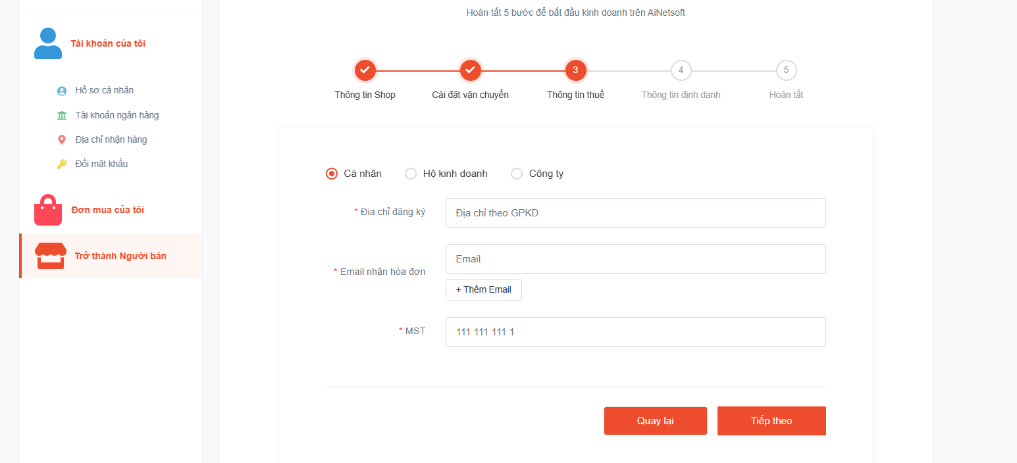
Personal business( Same screen for Company business)
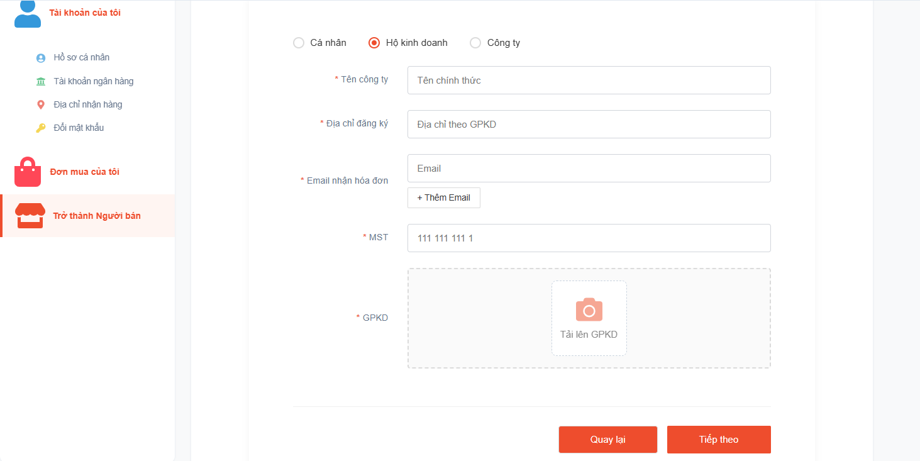

Users must fill the important information for business owner and will be scanned by AI system to validate the information
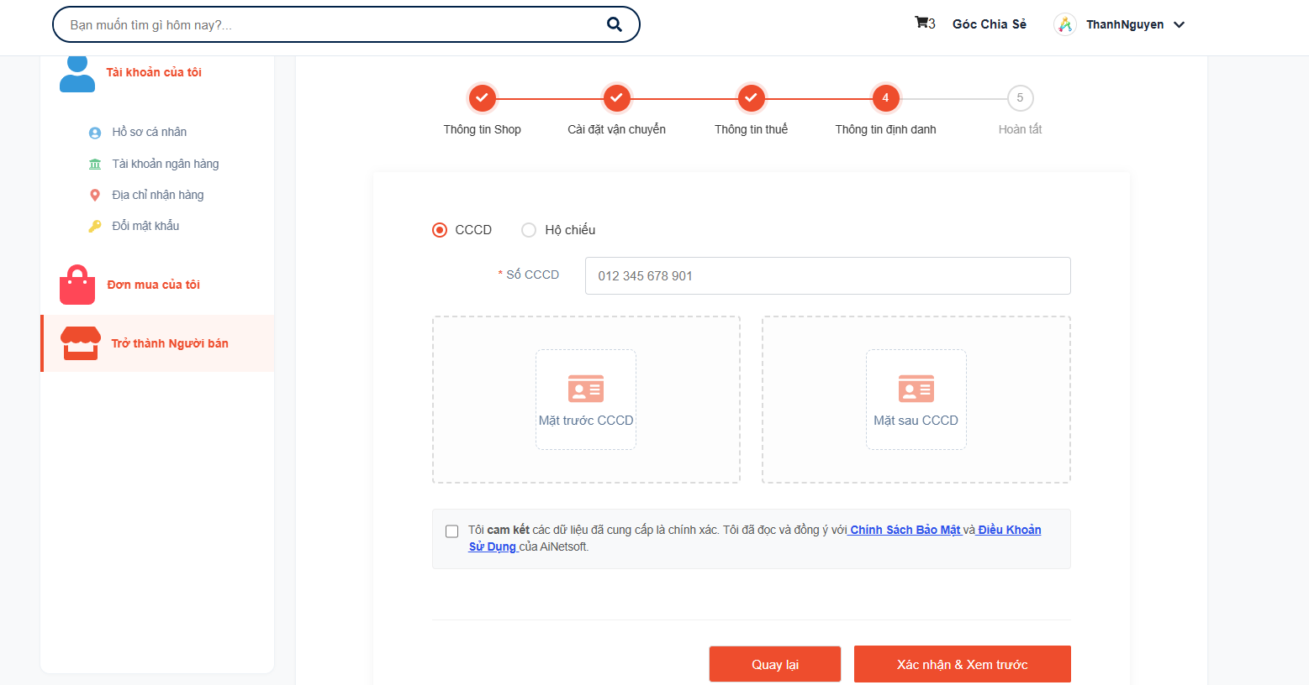

Users will be denied moving to next steps if checking failed the result and ask the user has to verify and update the correct information
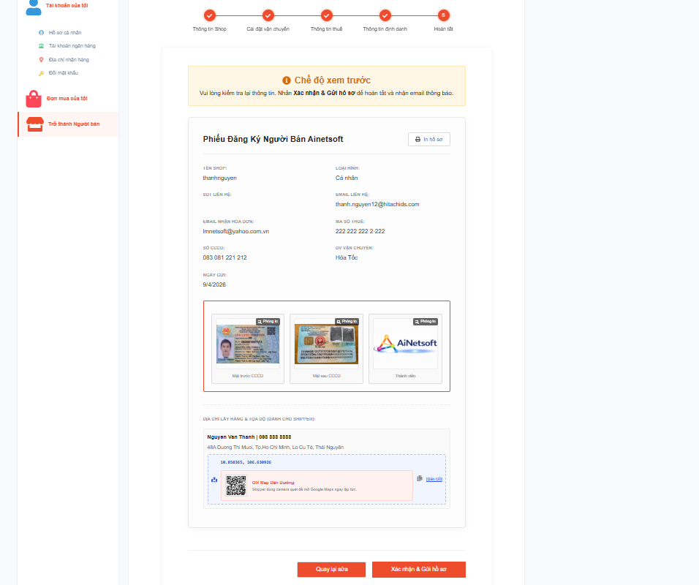

Showcase of invalid information checking
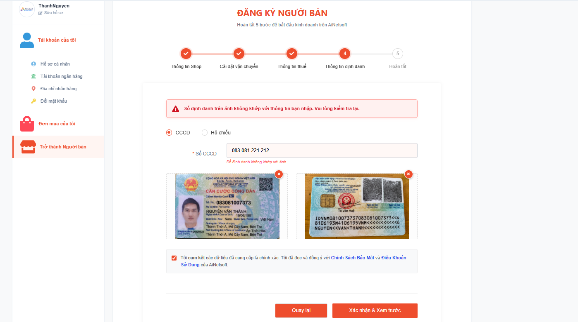

After all information needed id valid, the requester will receive the notification and email as below
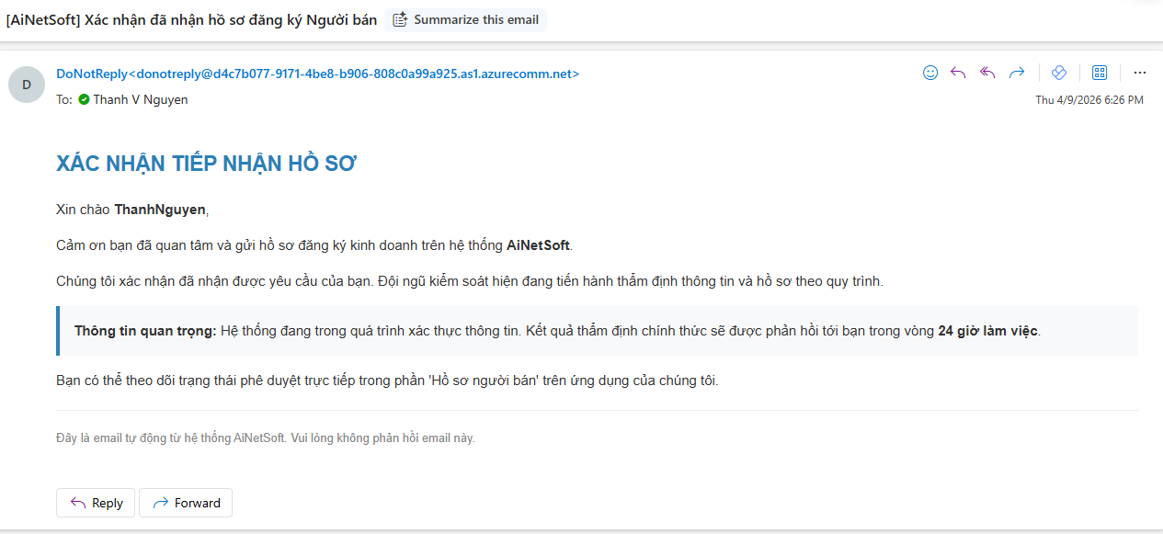

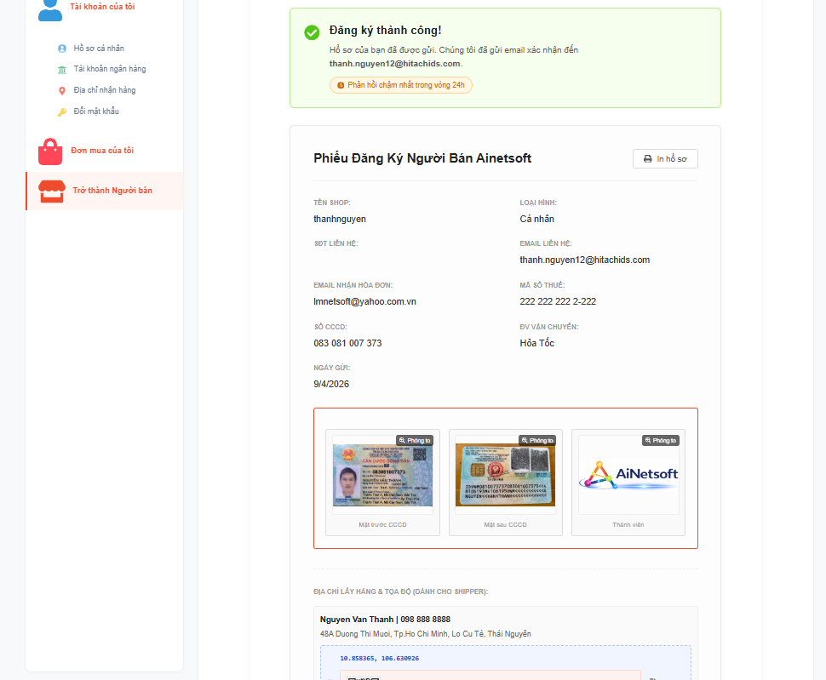

1. After sending the registration to become a seller and still waiting for approval:

- The user is still able to see the notification like:
- "Hồ sơ đang chờ phê duyệtYêu cầu đăng ký Người bán của bạn đã được tiếp nhận. Đội ngũ kiểm duyệt sẽ phản hồi trong vòng 24 giờ làm việc."
- An email to the requester to confirm admin received the request and will check and appove
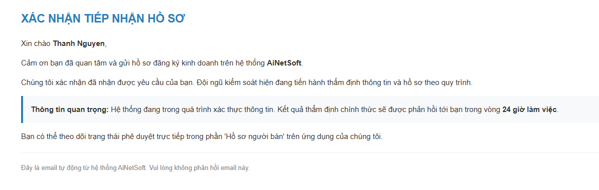
- In the time of waiting for approval, the user able to see the notification in the link /seller/register the progress of the status and a notification also appear "Đăng ký thành công!
Hồ sơ của bạn đã được gửi. Chúng tôi đã gửi email xác nhận đến pending@ainetsoft.com.

Phản hồi chậm nhất trong vòng 24h"
- When the seller submission is denied, a message will be raised in user dashboard like: "Hồ sơ bị từ chối
Lý do: Chụp lại ảnh CCCD.
Hệ thống không thể xác thực một số thông tin của bạn. Vui lòng kiểm tra lại lý do trên và cập nhật hồ sơ chính xác trước khi gửi lại."

A button also sees here to ask the user back from scratch and resend the "become seller" request again

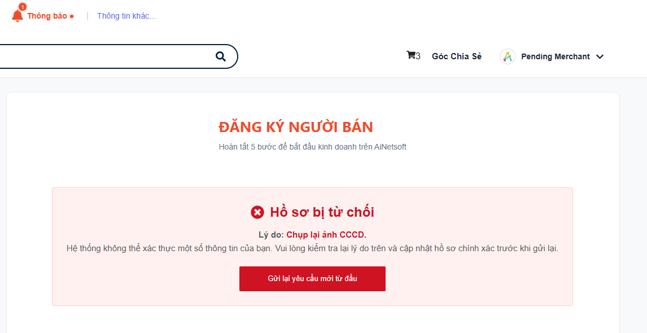
- In the Bell of Notification, there is also a message that tells the user that the request is not permitted

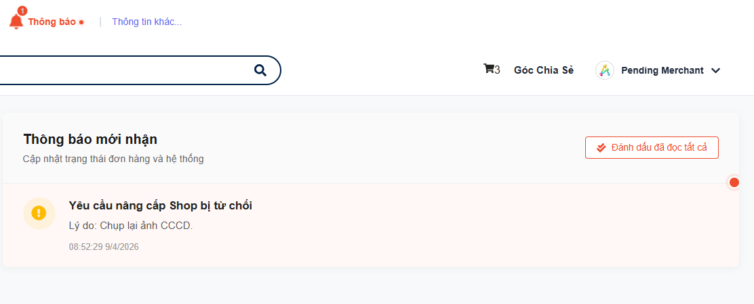
2. Approval:
- Seller receives a Bell notification as below
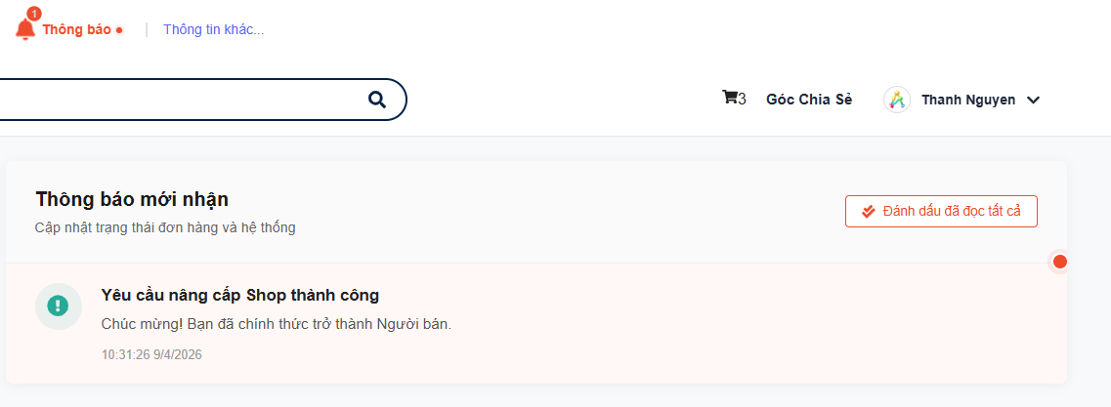
- An email sent to the seller as below:
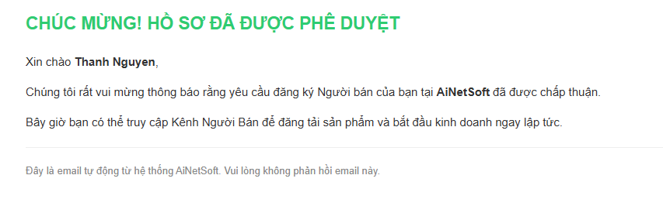
3. Seller Admin Dashboard
- After users became aware of being a Seller, the Admin dashboard as below
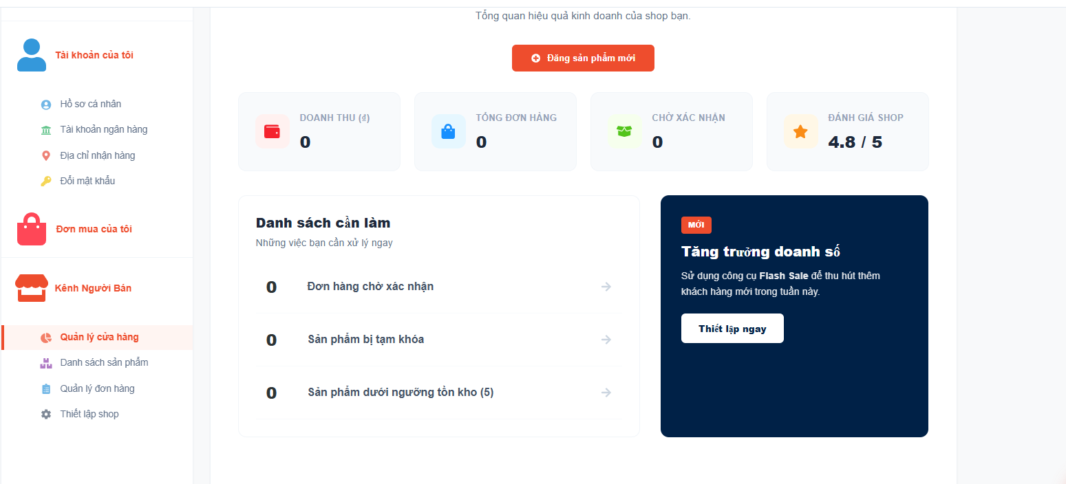

Danh sách sản phẩm:
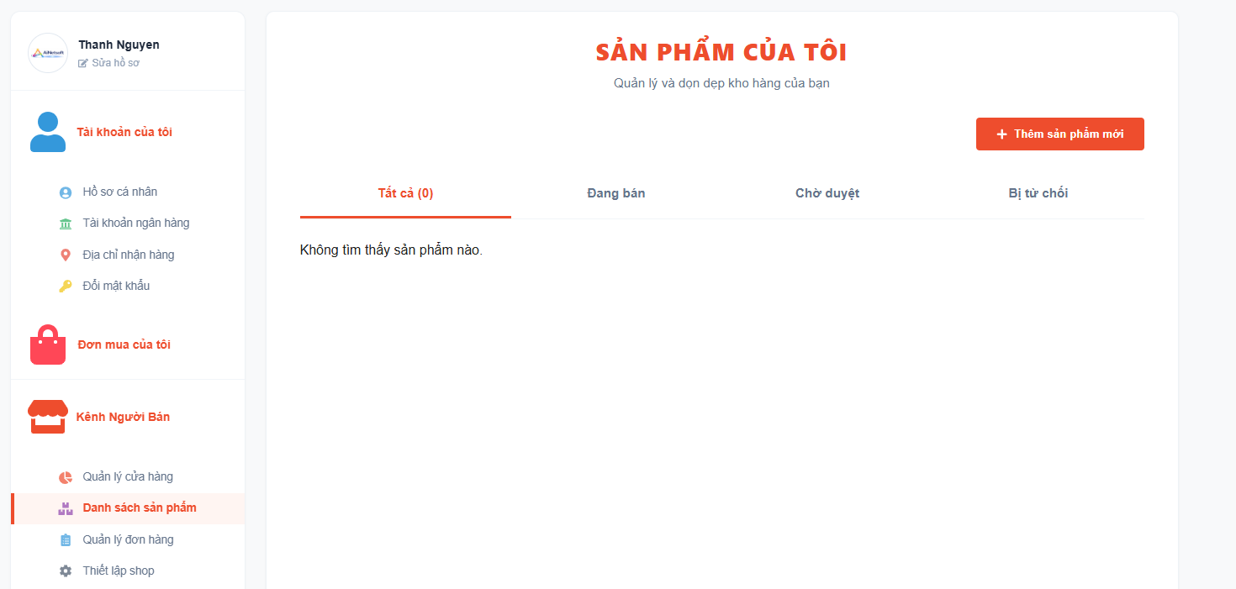

Quản lý đơn hang

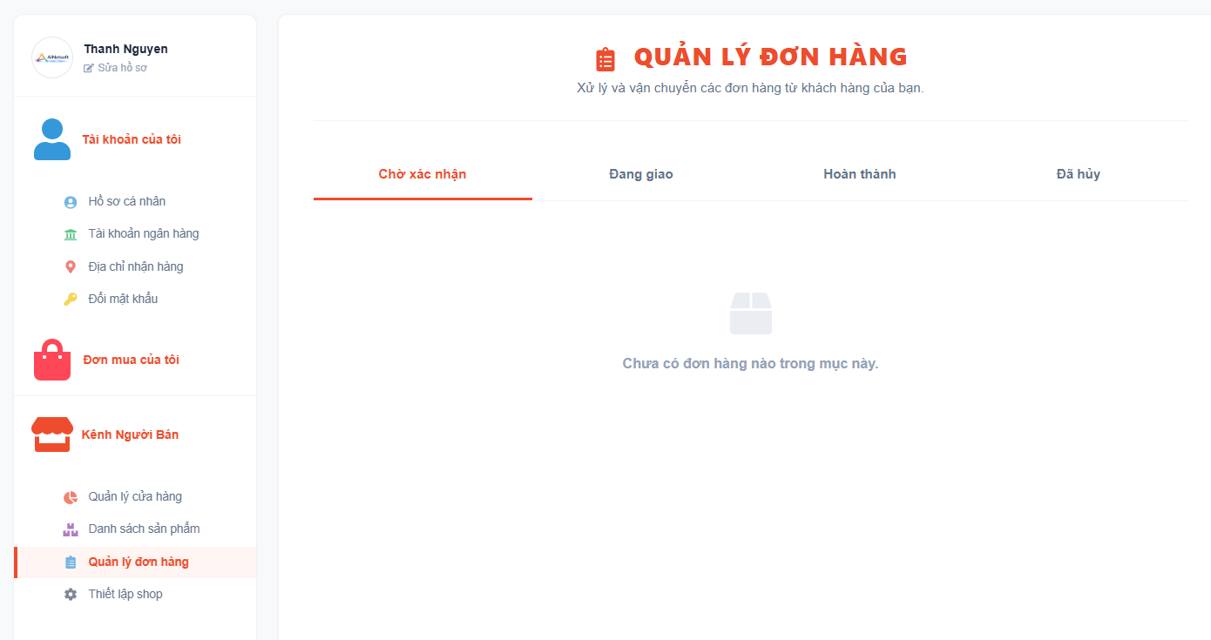

Thiết lập shop:
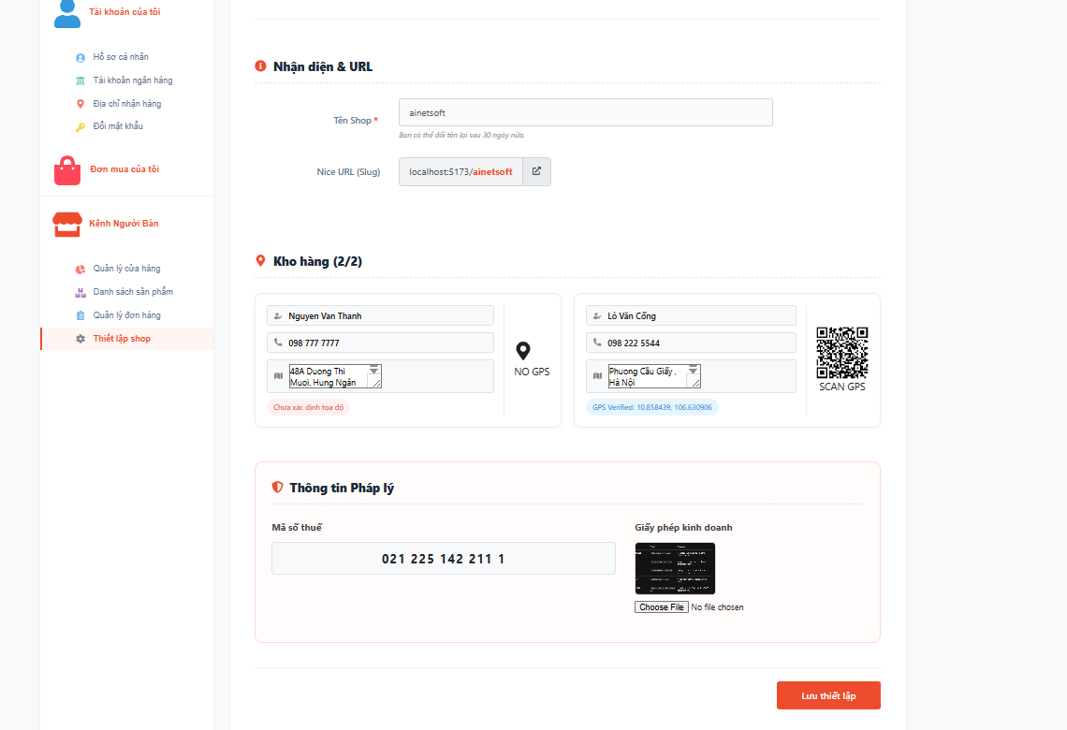

- Administrator:
- Database:
- Current collections are created:

# | Collection Name | Description
1 | audit_logs
2 | bank_accounts
3 | categories
4 | chat_messages
5 | content_nodes
6 | feedback_templates
7 | footer_icons
8 | footer_menus
9 | help_nodes
10 | notifications
11 | orders
12 | password_reset_tokens
13 | product_reports
14 | products
15 | report_reasons
16 | reviews
17 | shipping_methods
18 | system_contents
19 | users

